Scribbler Robot

Subject: Computer Science  Related Subjects:Computer Engineering | Grade Level(s):4&5  Length of Lesson: | Type: Inquiry / Design / Project  Keywords: Programming, Software, Code, GUI

Lesson Overview
The students will create a computer program using the GUI system that commands a Scribbler robot to spell out a word.

Lesson Focus
Students will practice developing one of the most valuable skills an engineer can have: computer programming. In this activity, they are tasked with developing a computer code on an intuitive graphical interface that commands Scribbler robots to complete certain tasks like playing a tune and writing out a word with a marker.

Lesson Objective(s) | Students will learn how programming works, and how to program robots to do simple tasks

Lesson Timing

5 minutes | Introduce the Lesson
30 minutes | ...

Materials | - Laptops for the class (1 per 2 students) with Scribbler GUI software installed  - Scribbler robots for the class (1 per laptop)  - USB cables (1 per robot)  - Extra AA batteries (20)  - Butcher paper (10 12X12 sheets  - 3 packs of colorful markers
Instructor Prep | - Familiarize students with robots by going through startup guide  - Watch short video on how to use scribbler robot GUI  - Let students make programs for robots to execute
Related Resources | - List related lessons/ppts etc available from USC or outside, trusted orgs

Lesson Plan

Introduction
In some ways robots are very much like us. Humans and robots share the same basic components.
 | Humans | Robots
Movable body | Human body | Housing
System to move the body | Muscles | Motor/actuators (CIRCUITS)
A sensory system | Eyes/nose/ears | Sensors (CIRCUITS) – for movement
A power source | Heart/lungs | Battery
A means of deciding what to do | Brain | Programmable computer

It is the last component, deciding what to do, that differentiates us the most from robots. Humans have free will. We can decide to do whatever we want. You all have decided to be here in mission science, and are deciding to sit still and listen right now. Robots do not have free will. They need detailed instructions about what to do. Humans give robots instructions in the form of a program. The ability to program a robot is also what sets robots apart from other machines. We don’t program our car to take us where we want to go, we have to drive the car. A robot, however, can be programed to drive a certain route or perform a certain task, with no input from the user after the writing of the initial program. In this way, robots are “smarter” than other machines, but at the end of the day, they are only as smart as their human programmers.

Robots also don’t have senses in the way that we do; they can’t taste, smell or “see.” Robots use sensors to guide movement and to prevent them from running into things. Robots are also not limited by the constraints of the human body. They don’t need to breathe or sleep. For this reason we can send robots to places where it is hard, or impossible, for us to go. Scientists, for example, sent a robot named curiosity to mars. Curiosity is programmed to move across the planet and gather information about a place that is very difficult for humans to go. Robots like the mars curiosity rover have made huge impacts on our world, all thanks to the teams of scientists who built and programmed them.

How do we program a robot? A program is a detailed set of instructions. We have to include all the details of what we want the robot to do, because it cannot think for itself. Let’s look at a simile robot, which is programmed to make a cup of tea. The program for this task would look like this:
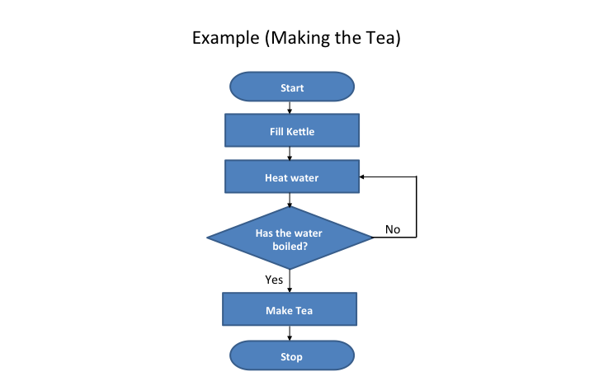
(example to be put on board for students to see)

Robots are also typically reprogrammable, as we will see today. We can tell a robot to do one thing, but if we change our mind, or need another task accomplished, we can reprogram the robot. Maybe you’d like a cookie to go with your tea…you don’t need to buy a new robot, you can simply program your robot to whip up a batch of chocolate chip cookies.
The robots we will be working with today don’t make tea (or cookies) but they can do lots of neat things like drive a specific path, spin, play music and light up. We will get familiar with our robots by going through a few demonstrations of their abilities. Next week, we will write our own programs to make our robots do what we want.

Procedure
List the steps of the activity. Remember to focus on leading students to the solution, rather than just telling them what to do. Include pictures of steps if you have them. Be sure to include some steps for discussion and reflection.

- Have students find a partner to work with and give each team pair a laptop, Scribbler robot and cable.
- Have the kids spend time identifying the different parts of the robot (USB port, lights, switches, sensors, etc.)
- Instruct the teams to open up the GUI software.
- Teach them the basics of the software. Explain that every code needs start and finish tiles, and the commands for the robot must be connected between these tiles. Notify that the can right-click and double-click on the tiles to change their settings.
- Have the class write a simple code to turn the robot’s lights on and off.
- Once every team has become more familiar with the software, start giving the class more difficult challenges.
  - NOTE: It may be a good idea to administer this lesson over two weeks if the kids struggle to complete simple tasks on the first day.
- Eventually work up to the ultimate task of having the robots spell out a simple word while playing a song.
  - Be sure to tape butcher paper to the ground and have students test their programs on this paper without pencils before you give them a marker. This way the class room floors will not be damaged.

Wrap-up
End the lesson with some final discussions about what students designed/discovered. Connect their activity back to the focus question/problem, real world examples, and STEM careers.

Also include notes about any special cleanup considerations

Lesson Background for Teachers

Suggested Real-World STEM Connections

Role Model in STEM

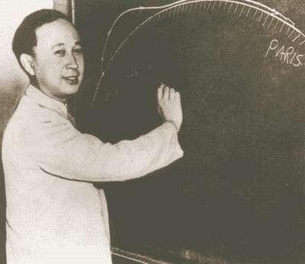
Name: Quan Xuesen
Years: 1911-2009
Quick Facts
- Father of Chinese space program
- Cofounder of Jet Propulsion Lab at Caltech (JPL)
- Named Person of the Year by Aviation Week and Space Technology

Source(s):
- https://en.wikipedia.org/wiki/Qian_Xuesen#Later_life
- Software developers all over the world work together to create apps like Uber and Facebook.
- Engineers at Apple use the principles of computer science to develop the iPhone’s iOS software.

Lesson Variations and Options
Include descriptions of alternative methods or ways to present things.

Explanation
Describe the background concepts and explanations behind the lesson. This can be more in depth than a teacher/instructor would actually share with students.

Key Concepts and Vocabulary
- Word 1: Grade Appropriate Definition
- Word 2: Grade Appropriate Definition

Safety Notes
- Safety instruction

